Development and Testing:

I decided to develop my game in a series of scripts (separate python files) which have different functions so that I can keep my ‘main’ code tidier.

# Draft 1

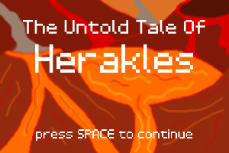The first draft was where I initially created my “title_screen”, “login_menu” and “main” scripts. The “title_screen” script would display my title image and make the user press space to continue; “login_menu” allows the user to enter his login details or create an account; “main” is the main script which determines when the other scripts are called and contains the game’s main loop. At this stage, I wanted to create a functioning start to my game so that I could fully focus on creating the game itself later in the development process. This consisted of displaying title screen, then when user presses the space bar the game will transition to a login menu. Once logged in, the game screen will be displayed, which so far was only a black screen.

Developing the “title_screen” script was straight forward; it successfully displays my title image and only allows for one input (the space bar) which stops the script’s loop and returns to the main script.

Figure 1: Title Screen

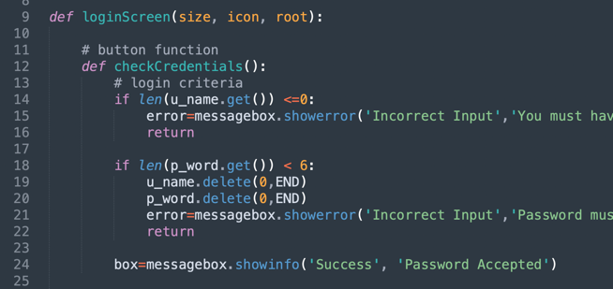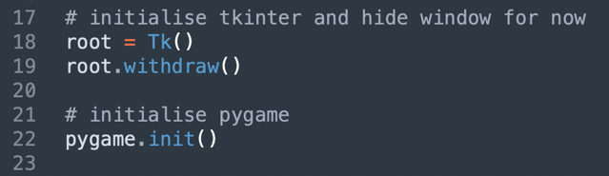Initialising both tkinter and pygame at the same time caused me some issues as this was my first time doing so. I initialised tkinter after pygame which caused errors. Once I figured out that I had to initialise tkinter first, my next problem was that a little black window (my root) would appear on screen which was unappealing. I then discovered the “withdraw” and “deiconify” functions that I would call upon my root to hide and display it.

Figure 2: Initialising Tkinter before Pygame

I initially tried to develop my login menu script using Pygame as my GUI library but when noticing that entering text into boxes was going to be more difficult than expected, I fell back on my original plan to use Tkinter.

My “login_menu” script at this stage was a simple interface including two text boxes, two entries and a button. I initially found the structure of this script to be a bit tricky, as each button had its own procedure. If I wrote these button procedures outside my login function, then I would have had to pass the root variable each time which I wanted to avoid. Therefore, the procedure for the button was written inside of main function for the screen, I acknowledged that this was an incorrect and messy way to structure of the code, but it was the only way that I thought of at the time. At this stage it was enough to pass, and I would make a note to come back to it and refactor the code later to make it more efficient.

Figure 3: The procedure inside the login function, to be refactored later

# Draft 2

The second draft is where I expanded my “login_menu” script and started writing the “database” script. The “database” script is the script which uses the SQLite3 library which allows python to execute SQL queries. I also decided to use SQLite3 instead of MySQL because SQLite3 creates a local database on the device (as a .db file in the same directory as the script it’s been created) which greatly simplifies connecting to the database.

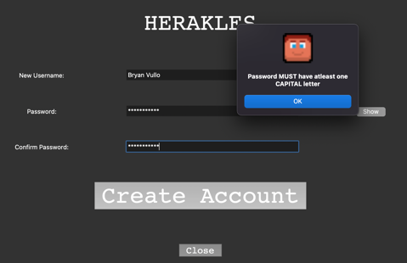My main priority at this stage was making the login menu user interface functional (front end) before connecting and making changes to the database; this started with allowing the option to create an account. I added a button which when pressed hides the ‘login’ menu and displays the ‘create an account’ menu which was slightly different such as the extra entry field which make the user confirm their password (Fig. 5). The next step was to hide the user’s password with asterisks (*) as they typed it in for security reasons; introducing another button which allows the user to toggle if they would like to show/hide their password (Fig. 4). Finally, I added checks to the entered details to make sure they fit certain requirements, these include must have a capital letter, number, special character in their password, it being at least 6 characters long and for a username to be entered. Extra checks made for the ‘create an account’ menu such as the two entered passwords to be exact for confirmation. These checks throw pop-up windows notifying the user if their credentials have been accepted and if not, for what reason they weren’t (Fig. 6).

Figure 5: Create an Account Menu

Figure 4: Login Menu with new features

Figure 6: Example of a pop-up window from credential checks

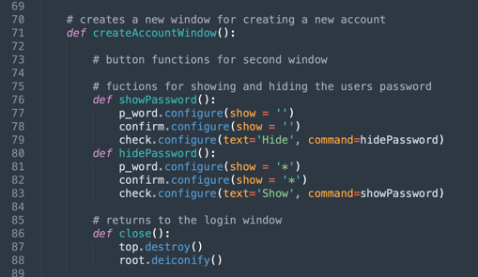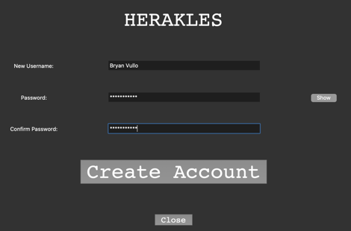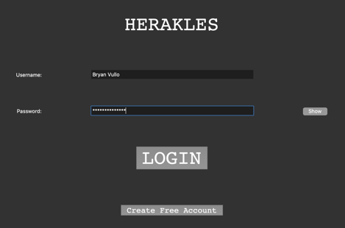The code at this stage with the procedures within the function started to get messy (Fig. 7) as I created more and more buttons which all needed their own procedures. I didn’t fix this issue just yet though.

The issue I noticed before it became a larger problem was the fact that if the user exited out of the login menu, skipping the login process entirely, the pygame window would appear as if the user successfully logged in. This would be a massive problem later in the project because to start the game, I would have to load data from their save file so if they never logged in then this would lead to the game crashing and throwing up errors. I fixed this by simply creating a procedure that is run when the user tries to exit out of the window which displays a pop-up message asking the user for confirmation if they would like to exit the game. If yes then the whole program is exited instead of just the one script, and if not then the tkinter window will continue being displayed.

Figure 7: A procedure within a procedure within a procedure... messy

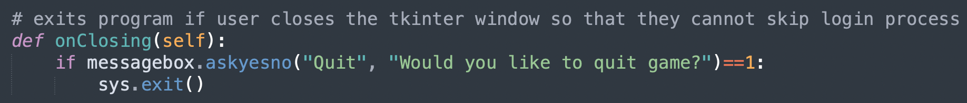

# Draft 3

With the user interface made, this stage was to create all the backend functionality to the login system. In this stage, I greatly expanded my ‘database’ script and created my ‘credentials’ script. The database script now creates the main ‘accounts’ table on the first run on the game as it doesn’t exist yet. 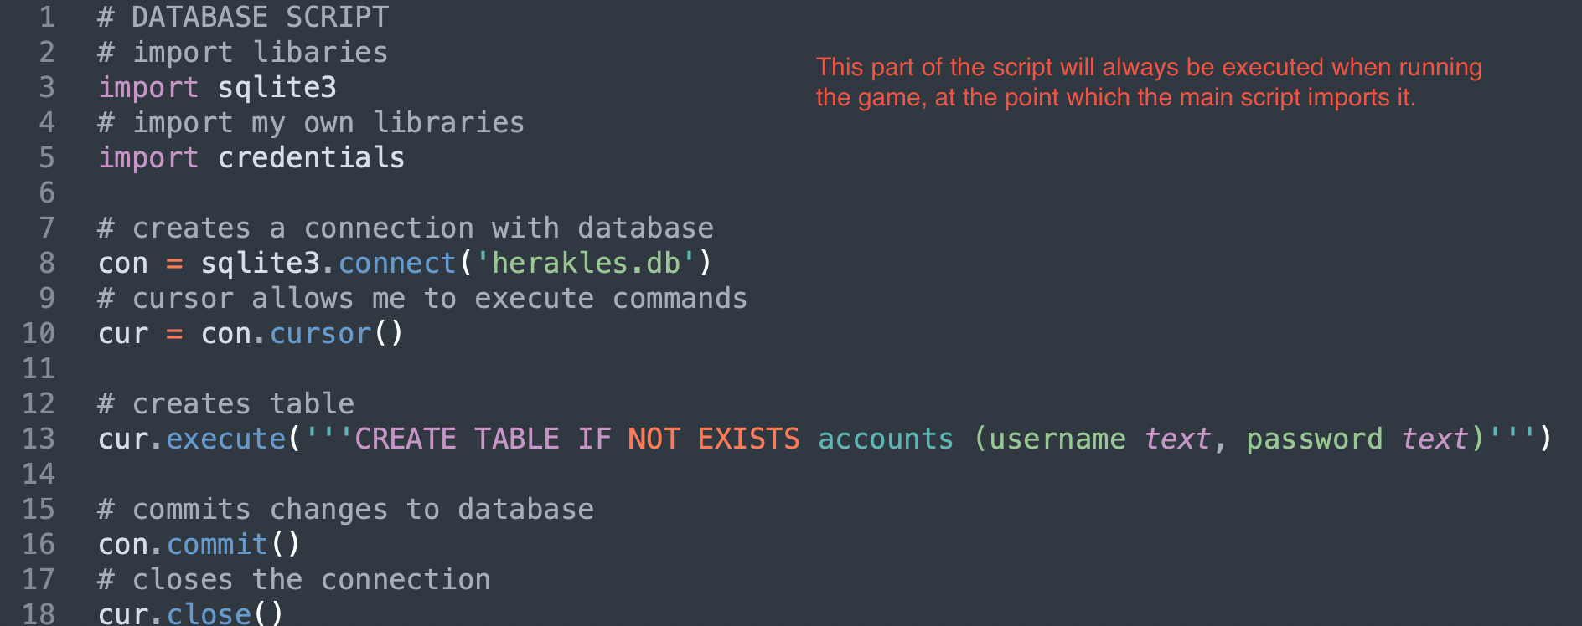

Here, I made three functions in my database script: ‘isAccount’, ‘createAccount’ and ‘loadData’.

The function ‘isAccount’ takes the player’s username and password as the two parameters, from the two tkinter entry fields. It then connects to the database and searches the ‘accounts’ table for a record with the username and password given, if an account is found then the function returns ‘True’, if not it returns ‘False’. This function is used during the login process. 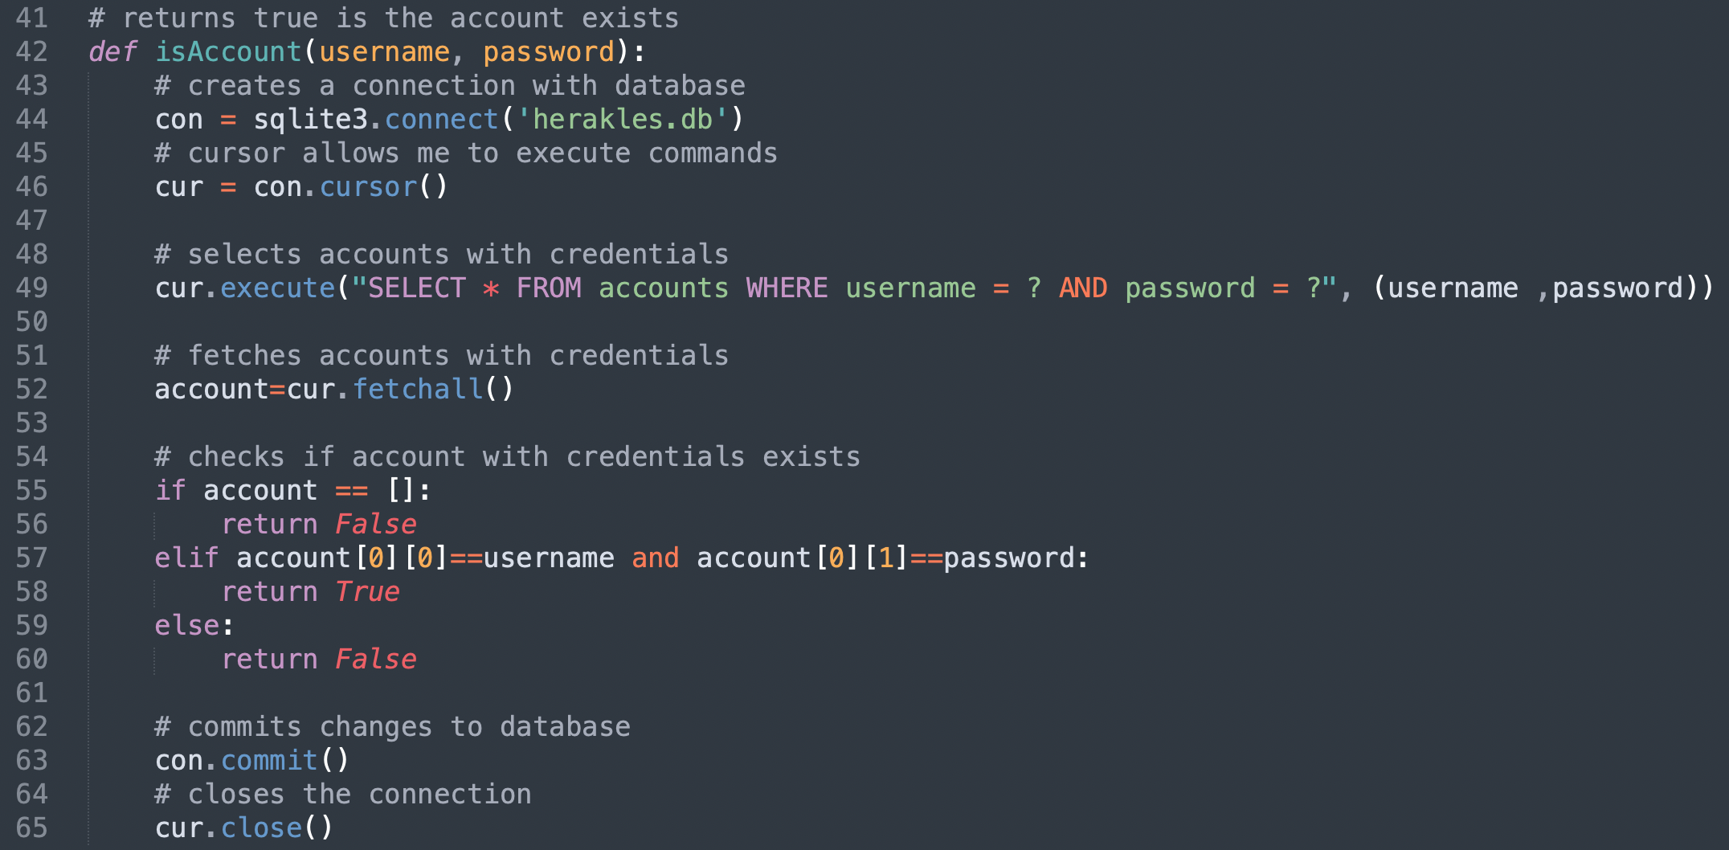

The ‘createAccount’ function takes the player’s username and password from the ‘create an account’ window’s entry fields as parameters, connects to the database and creates a new record in the ‘accounts’ table.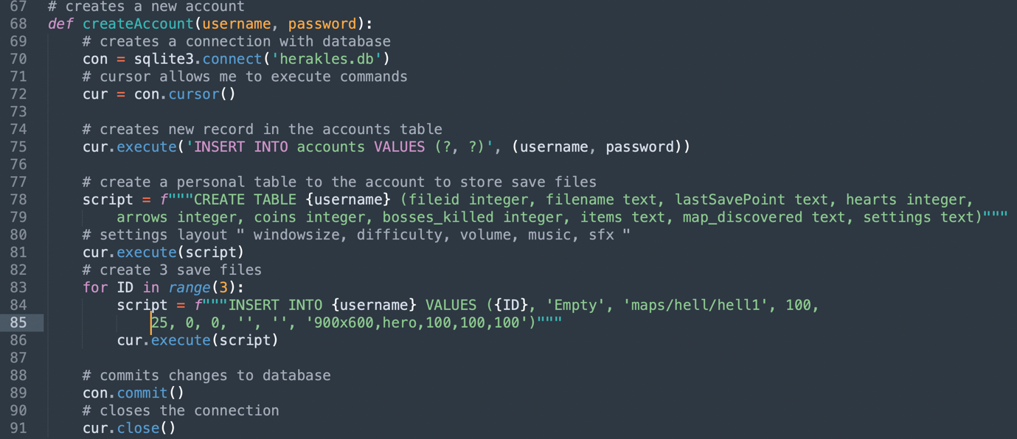

The third function, ‘loadCredentials’, again takes the player’s username and password as parameters, connects to the database and retrieves their record from the ‘accounts’ table and returns the whole record.

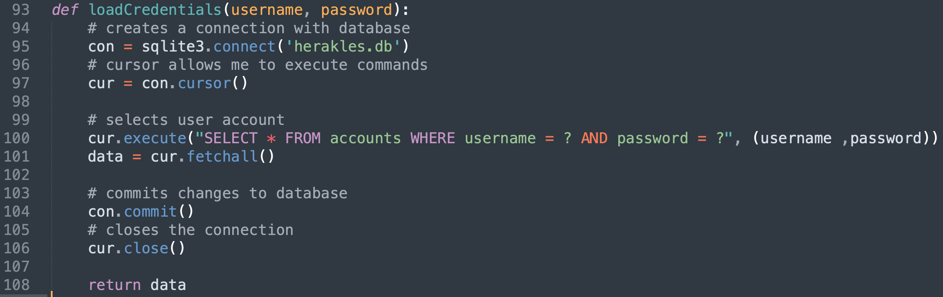

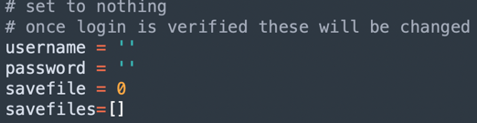The ‘credentials’ script isn’t much of a script as it’s implemented more like temporary storage for easy access from other script. This was my solution to the problem that tkinter cannot return data as it’s simply a GUI library and the only way to return from it to the main script is to destroy the root. Therefore, I’ve had to implement the ‘credentials’ script which is used to store the user’s credentials as two variables; once the user is logged in and confirmed from my database function but before the tkinter script terminates, the variables within the credentials are called to store the user’s credentials from the login script. Then, when the program returns to the main script, the credentials script is used to retrieve the user’s credentials to load their data straight into the main script to be used within the rest of the game.

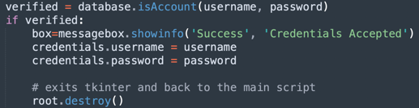The credentials variables are initialised in the script. Then used to store data in the login menu. Finally, the data is retrieved in the main script.

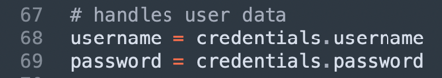

# Draft 4

In the fourth draft, I decided to develop loading the save files. To do this, I implemented a save file select menu where the user can select one of his three save files on his account. This process starts from the main script which now has the user’s credentials from the login process, which now loads the user’s table of save files, with the ‘loadSavefiles’ function in the database script and stores the save files in the credentials file temporarily as a list of three, from here the ‘display_savefiles’ script is called which extracts some data from each save file and displays them in a Tkinter window. Once the user chooses a save file, the index of the save file is stored in the credentials file under the variable ‘savefile’. The program returns to the main script and loads the selected savefile into the main script, using the ‘loadSavefile’ function in the database script. In the selection menu, the user also has the option to rename and delete the save files. Now the program is ready to start the game.

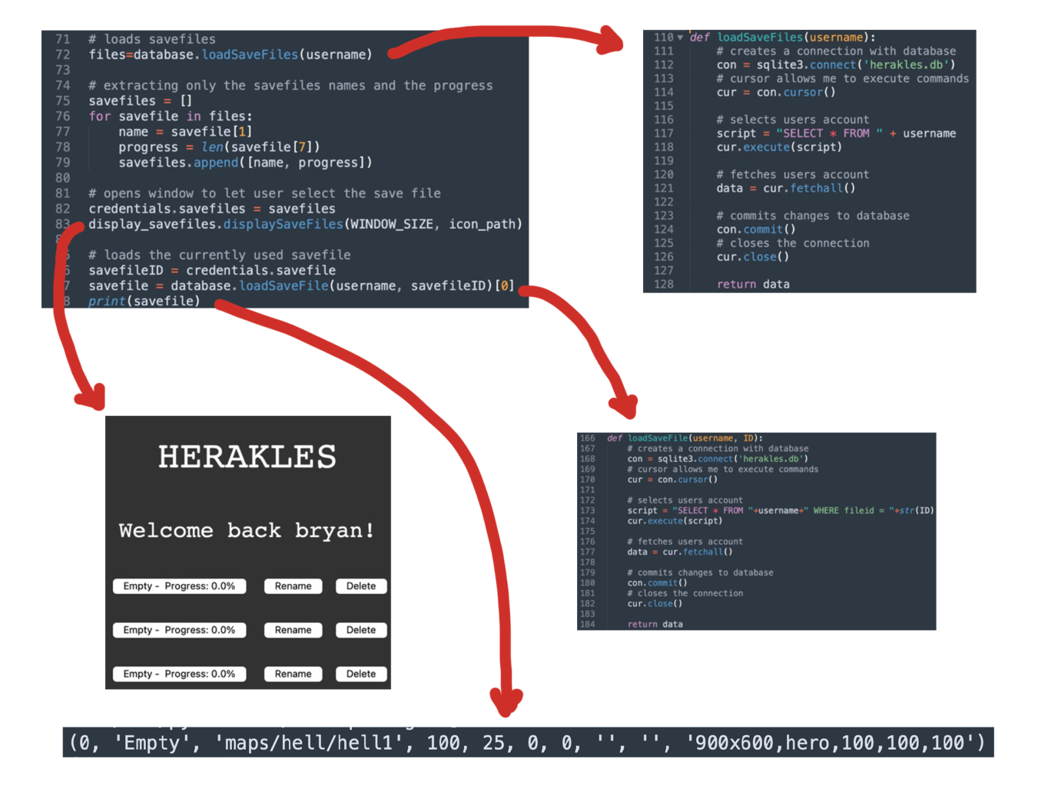

# Draft 5

In the fifth draft, I decided to develop on loading the game up. For the rest of the project, many of the improvements and changes will be made in the main script and the engine script. The engine script is the script where all the classes I’ll be using in the game are contained and where I hide most of the game logic to make my main script more organised.

Firstly, I created a dummy csv file which contains a 2D array of values, each value represents a 16x16 tile in my game, and imported that into my main script. From there, I created a dictionary in my main script which links each of those values to a path to the image file. Then in the game loop, I loop through the 2D array using two for loops, and create the rect for the tile, append it to a tiles list and then display the tile’s image.

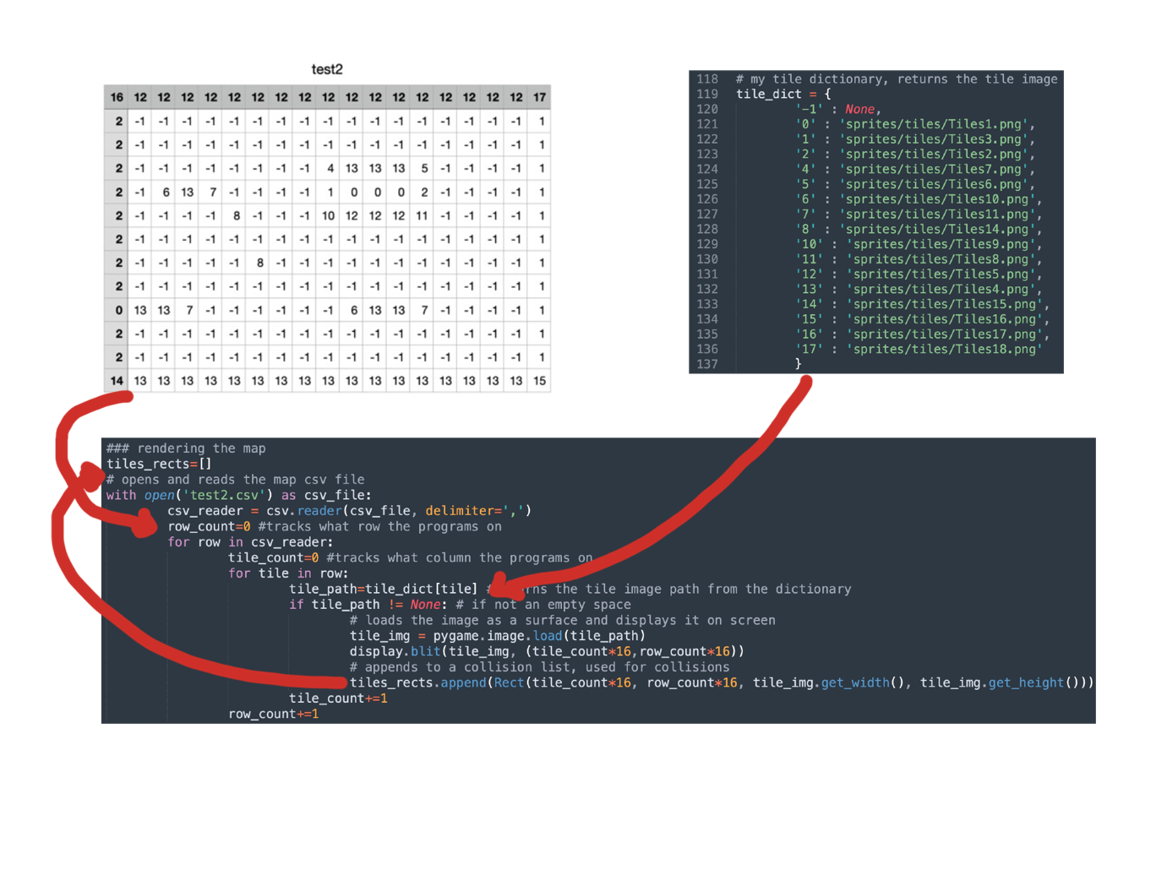

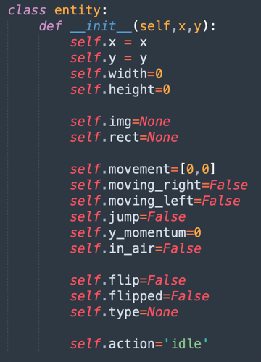

Secondly, in the engine script, I defined an entity class which will be used for my player, the player is defined with attributes at the start of the game, such as the player’s image object, rect object, dimensions, and action placeholders i.e., jump, in air, moving right, moving left and flip. This system is useful as I can now access everything, I need about the player in one object. Depending on each keystroke, the players attributes are changed to true or false and the actions on the player are made on the next iteration of the game loop. Pygame use objects called ‘rects’ and ‘masks’ for collisions not the image object so I need to define both separately for each object I would like to display onto my screen.

Secondly, I defined a class called ‘physics’ which will contain all the sub-routines needed for collisions, so they are easy to access under one class.

My first issue with collisions was when trying to rectify the two object’s positions. For example, in which direction do I move the player when he walks into a wall. For this I created two functions, the first takes an object and a list of objects and checks for collisions between them. The second function takes the player, the list of tiles and the player’s movement values for that frame. It separates the player movement into two vectors, horizontal and vertical movement. Moves the player in the horizontal vector first, checks for collisions using the first function, then moves the player in the horizontal vector and then checks for collision again. Then using the values for each vector, I can determine if the player was moving left, right, up or down and determine where to rectify the player’s position. The function also returns a dictionary which tells me in which direction the collisions occurred, this is used in my main script to calculate if the player is in the air or not.

Now when running the game, a map and player would be displayed and allows the user to move the player.

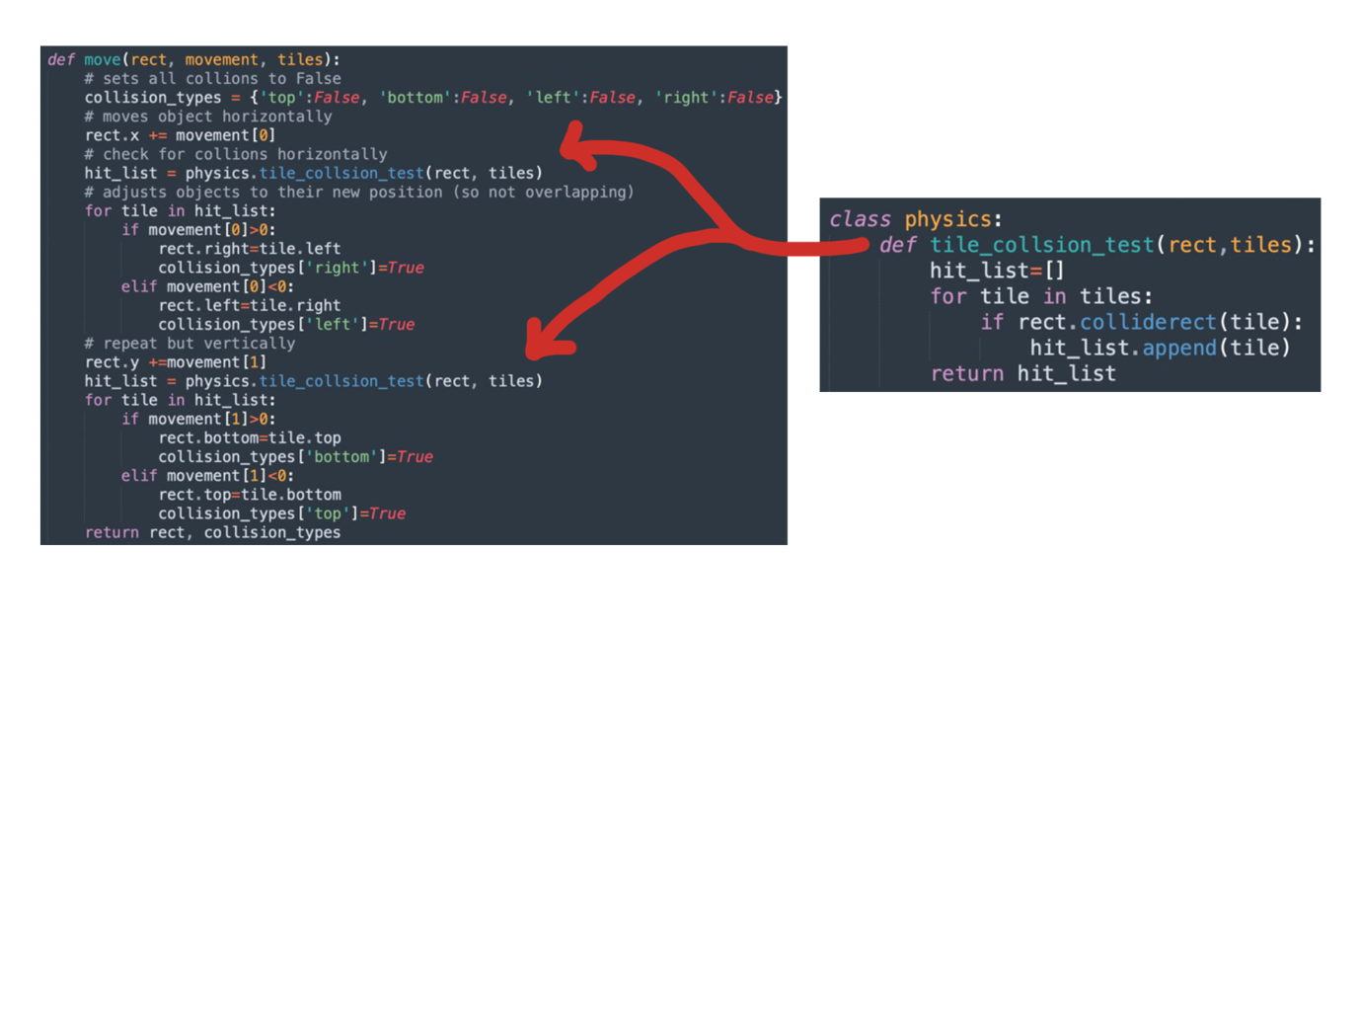

# Draft 6

Now with the foundations of the game built, in this draft, I decided to build more features and make my code more efficient and simpler. This includes creating more modules in my engine script.

The first feature I wanted to develop was a simple one, I wanted the player to always be in the middle of the screen and for the background to move. To do this I created a scroll list of two values, an x and y value. The scroll value determines how far the player has moved from the top left corner of the screen and I would apply this value to all my coordinates when displaying my images so that every image is relative to my player’s image.

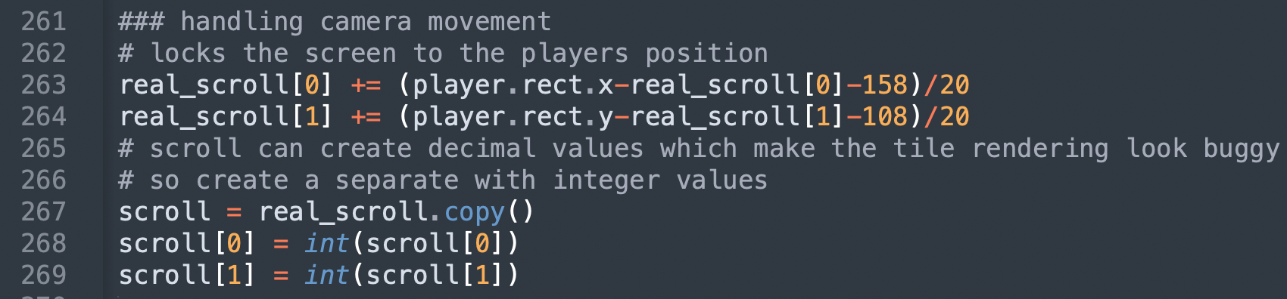

I also altered the math a little so that the player is slightly off centre in the direction he is moving in to create a more fluid motion rather than the player being fixed in the middle of the screen. This came with the problem that this scroll value would sometimes be decimal which would make rendering images look slightly out of sync with another. To fix this, I created a copy of the scroll variable and turned each of the values into integers and used that instead when displaying the images.

The first thing I wanted to develop was an animation system in my engine script. I decided to structure this by using two different dictionaries. “Animations” which relates each frames’ animation ID with the image paths of each frame in order. “Animation_images” which relates an image path to a Pygame image object. This allows me to load each animation at the start once then call to these dictionaries to assign the image for that frame. In the game loop, all I need to do to change an animation is fetch the frame’s action ID from the Animation dictionary depending on the current action and the stage at which the animation is at. Then get the specific frame’s image path using the action ID as an index.

For clarity, this is the structure of the two dictionaries:

This image is the structure of the Animation dictionary. Each animation, e.g. ‘club/idle’ has a list of action IDs, each ID is a single frame in that animation, that’s why the IDs are repeated as I want to show these images for multiple frames.



This image shows the structure of the Animation_images dictionary. Each action ID relates to a Pygame Surface object, i.e. an image.

Finally, to display the image, fetch the Pygame image object using the “Animation_images” dictionary and the frame’s image path. To do this, I created a function under the entity class called “set_anim_image” which takes an animation ID and does the computation explained above.

In the main loop, the action frame is incremented, if the animation ended then it would repeat, except special cases described below in the code.

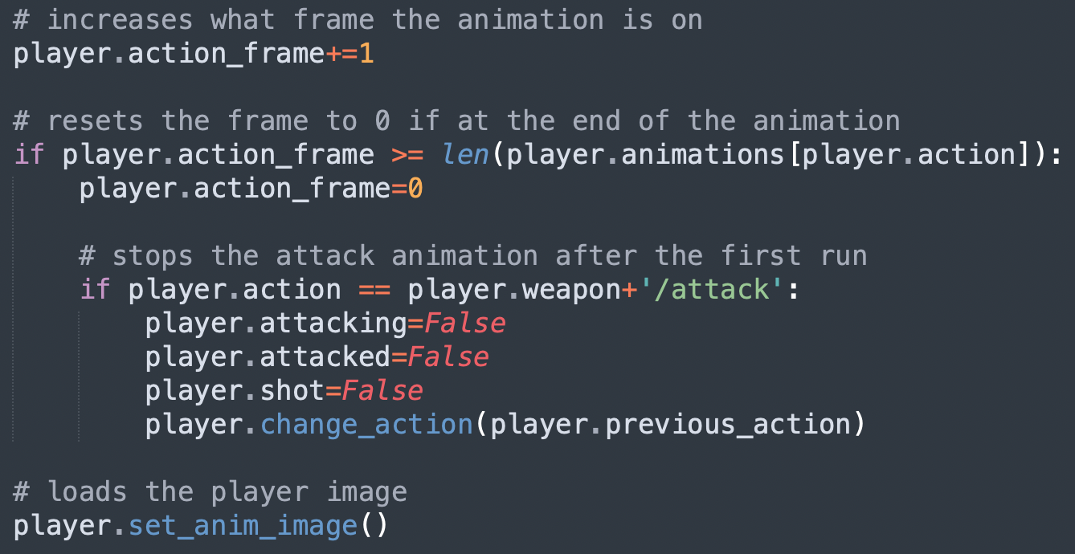

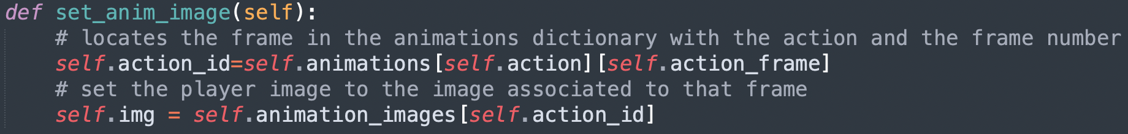

To change the animation, I created another function under the entity class called “change_action” which compares the new action to its current, if different it then sets the new action as its current and the current as the previous. I store the previous as I would like to switch back to the previous action once certain actions play once, for example attacking.

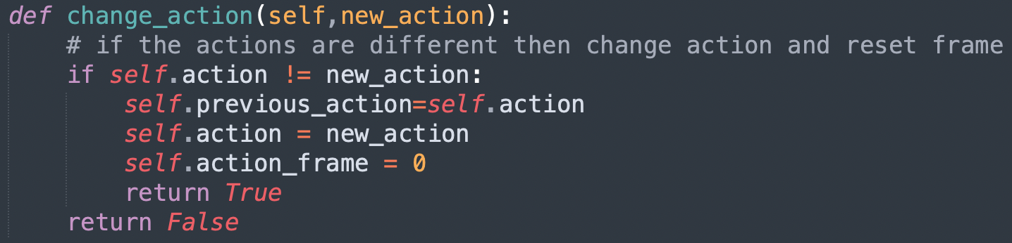

Secondly, I wanted to create a map loader system in my engine script, which takes a CSV file and returns a 2D array of values. This is like before but instead of fetching the data from the file each game loop, I could load it once before the room is loaded and have it until the room changes, this makes my code more efficient. 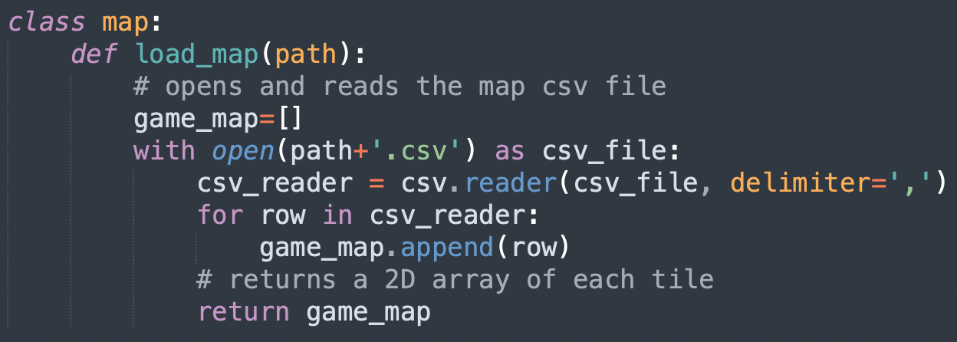

Thirdly, I didn’t like how I was creating each tile a rect and its image in the game loop separately. So, in my engine script, I created a “tile” class which encapsulates the tile image, rect and mask all in one object which is tidier.

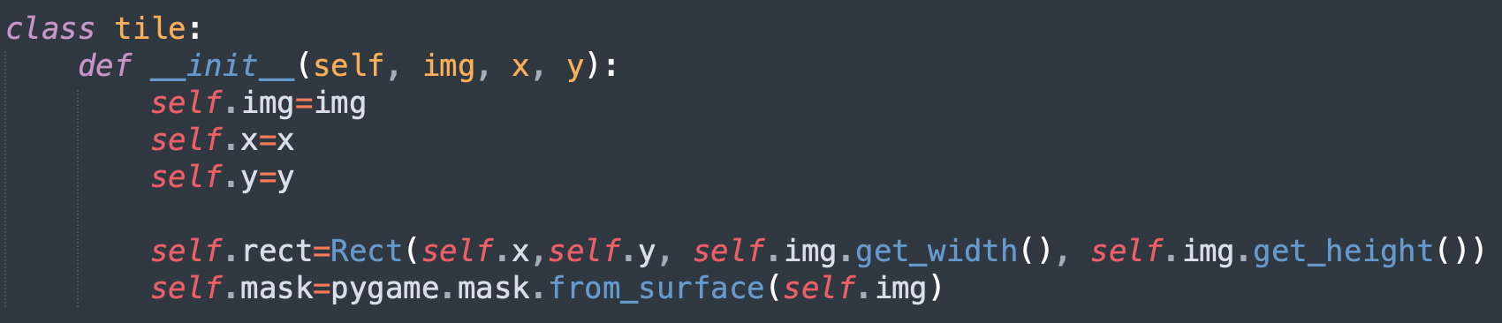

Fourthly, I wanted to implement my player having a bow and being able to shoot arrows as previously the player would only have a club. But firstly, I wanted to display a cursor on screen whenever the player has the bow equipped, wherever the mouse was. Which was as simple as fetching the mouse position each frame, taking into consideration the scale of the window as it gets scaled up. Then displaying the cursor image on screen at the mouse’s coordinates.

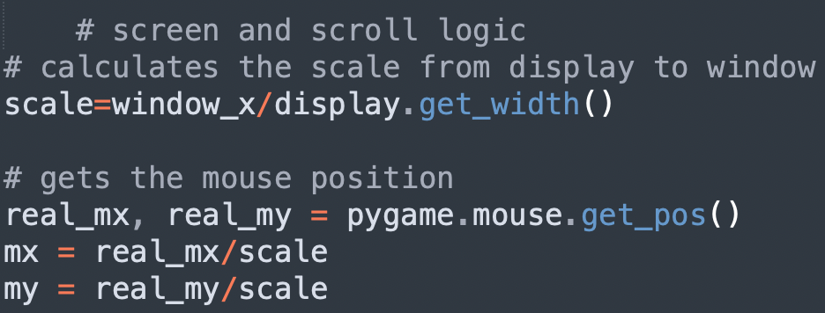

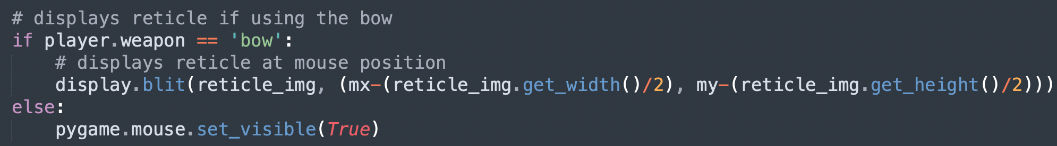

Implementing the bow was easy, I just needed to load new animations before the game loop started and assign new keystrokes to the actions attack and switch weapons.

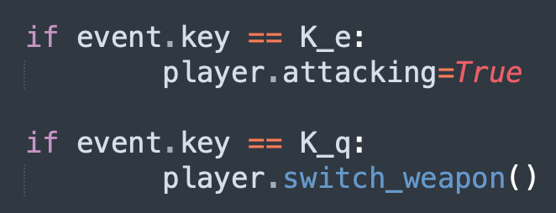

For the arrows, I created a new class in my engine script which creates a new arrow with its own rect and Pygame image. Then I needed to assign the arrow its position taking into consideration the scroll variable in that frame. This all happens when the player is attacking and is using the bow and has at least one arrow. 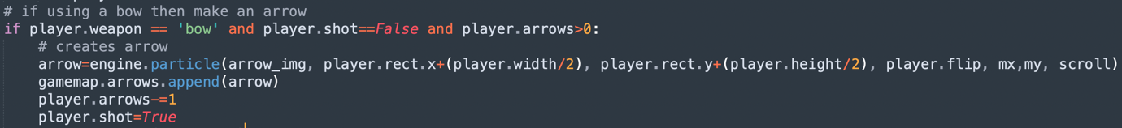

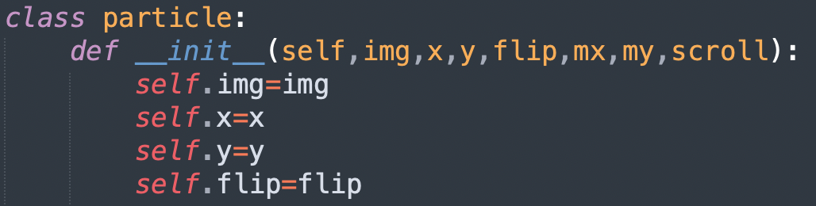

Then I wanted the arrow to move in the vector between the player and the cursor position and for the arrow image to rotate to that vector which took some math to calculate.

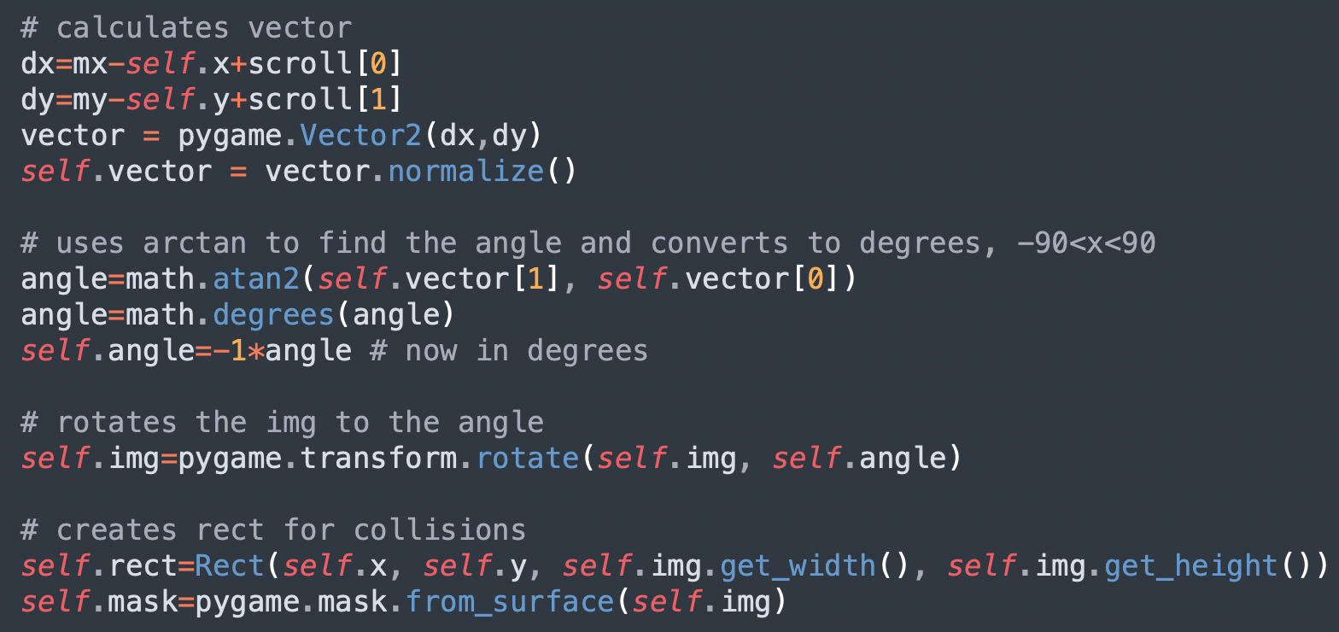

I then implemented collisions using rects between the arrow and the tiles, so that when an arrow collides with a tile it would be destroyed. This came with a problem that the arrow rect was made much larger due to the rotation and therefore collisions with the arrows and tiles were inaccurate. So, I then implemented collisions using masks instead of rects as they calculate collisions pixel by pixel instead of much larger rectangles to rectangles. As I read using masks for collisions was computationally more difficult than using rects in the Pygame documentation, I opted to check for collisions with rects first and if that was true then check for collisions using masks and if they were both true then destroy the arrow instead of solely using masks as this would be inefficient and could slow the program down if there was lots of arrows and other particles on screen.

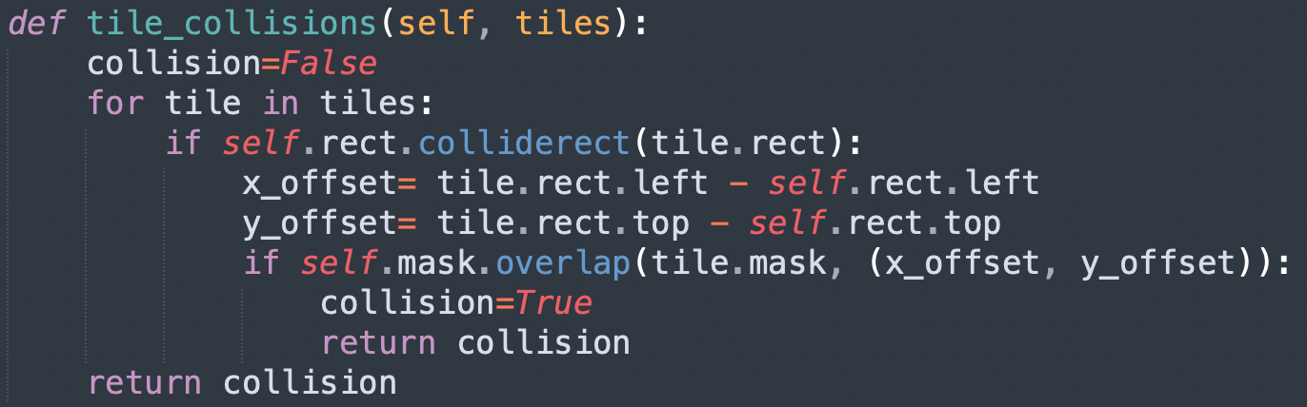

I also altered the main script from the last draft so that I display all my images at the end of each iteration of the game loop for tidiness, after all the calculations about what was happening in each frame.

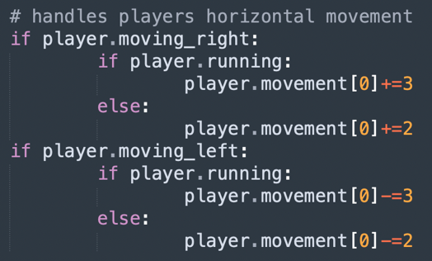

Finally, I wanted to implement the feature to make my player sprint, for this I created a new keystroke assignment and made it so when the user is holding down the shift key the player would move at a larger speed.

# Draft 7

In my seventh draft, I decided to go back and refactor my code to make it more efficient and shorter. I started with the animation loading and created a loop instead of individually loading each animation. 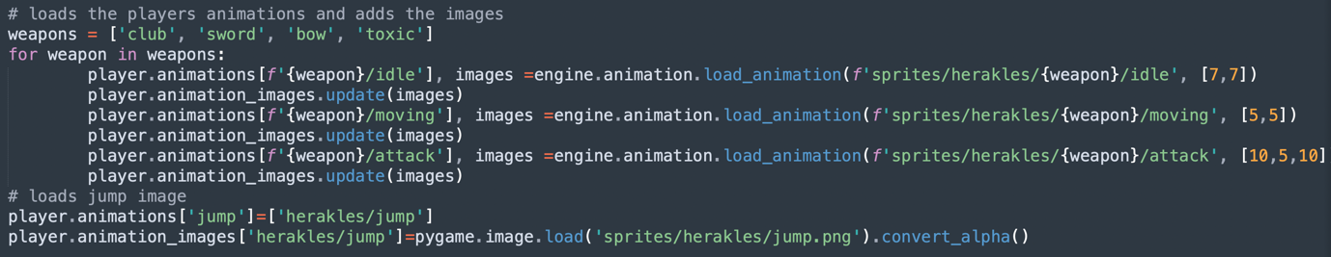

I also refactored my login menu using a class system to fix the issue of having functions within functions. This also helped reduce the number of parameters I was passing into functions as I could now save some values, such as window size and the icon, as attributes in the class and use them in all the other functions.

Below is a short sample of the new class system, compared to the previous script.

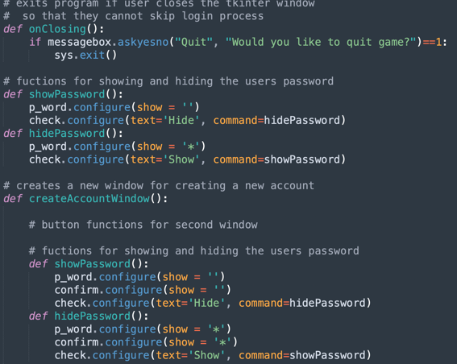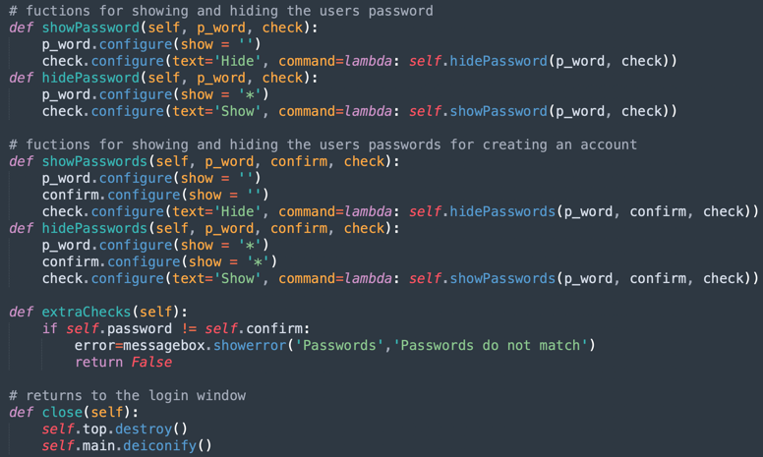

# Draft 8

In my eighth draft, I decided to create the game HUD. Firstly, I needed to create the player’s heart, arrow and coin counters on screen. Secondly, I needed to implement menus in my game such as the settings menu and the progress menu. I also wanted to save the changes so that the next time the user opens the game, you find the settings the same way he left it.

To create the player’s counter, I firstly displayed the icons for each item in the top left corner of the screen. For the numbers, I decided to create my own font class which takes a sprite sheet of characters, individually splits the characters into Pygame image objects using the “clip” function I created and stores them in a dictionary with their string counterpart as the key. I then created a method which takes a string, surface and location as parameters and displays the Pygame images of each character of the string on the surface given starting from the location given. With this, I can then call this method at the end of the game loop where I display all my images to display the counters’ values.

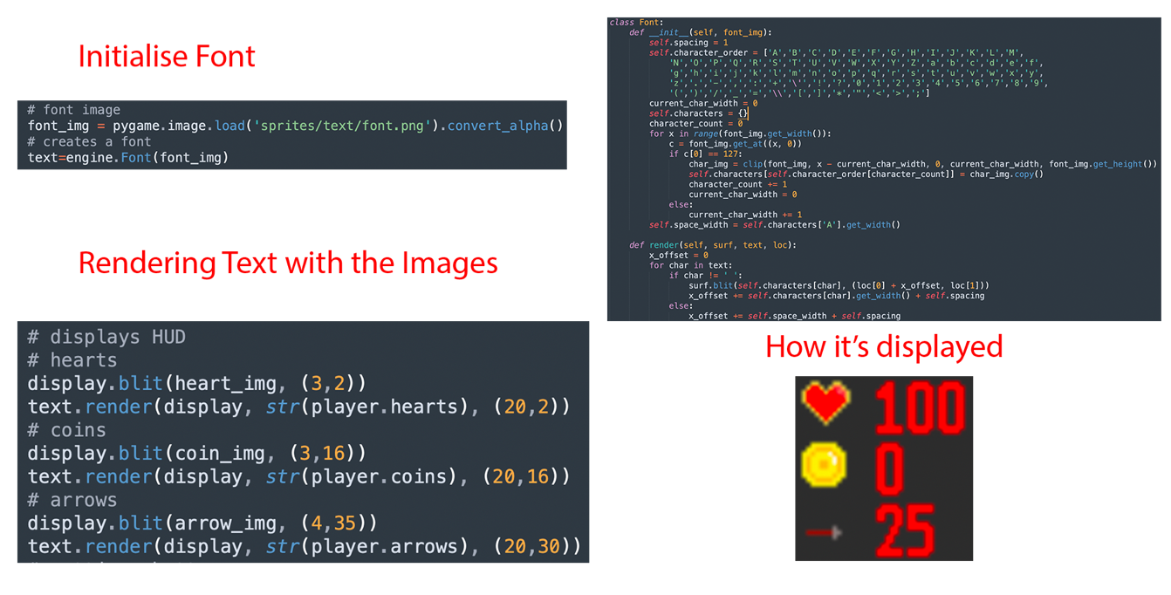

For the menus, I created separate scripts for each, “progress_menu” and “settings_menu”. They both use Tkinter as the GUI library to create the menu. I decided to create the settings menu first, which allows the user to change the window size of the game, difficulty, general volume, music volume, sound effects volume. There is also a button to save the changes and if the user tries to exit the menu a pop-up menu appears warning the user that unsaved changes will be lost. The save command calls to a new function from the database script which is called “save_settings” which saves the settings to the save file. Then the settings are also saved in the credentials file for the main scripts access.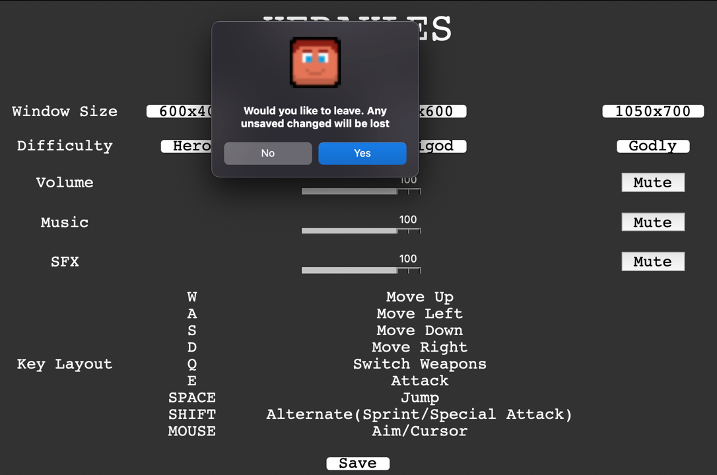

The progress menu script also displays a menu, which allows the player to switch between three menus: Map, Character, and Progress. But I left these menus empty as the game isn’t developed enough to display these menus yet. For example, I still don’t have a map to put in the map menu and I haven’t implemented the game’s story for the progress and character’s menu.

To integrate these menus into the game, I created a button class in my engine script which takes an image and coordinates as parameters and encapsulates the Pygame image, the coordinate values and the button rect in a single object. 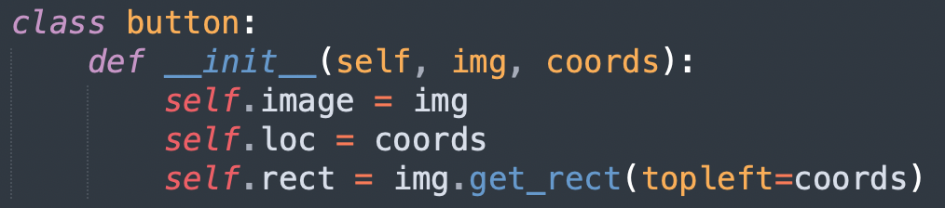

I then displayed the button images in the display section in the game loop. To make it interactable, I made a ‘if’ statement in the game loop which checks if the cursor is being clicked and if the cursor is colliding with the button rect, if so then the Pygame window is hidden, and the respective menu scripts are run. After the settings menu is run, the Pygame window is resized to the new window size and the new save file is loaded.

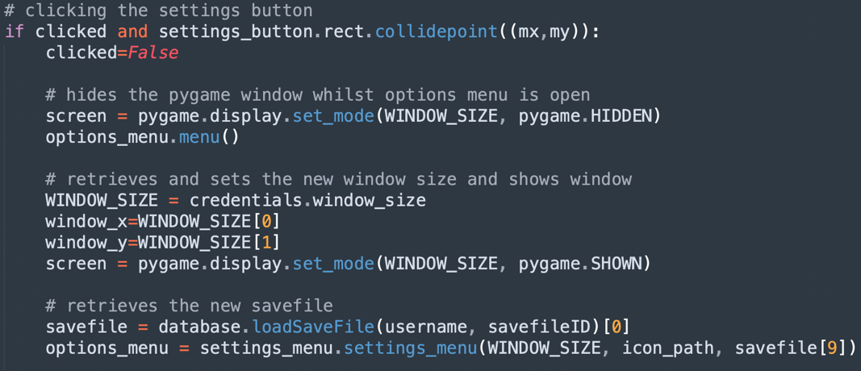

One problem, however, was with the Fullscreen functionality of the game. As the game wasn’t made to perfect scale with my monitor’s dimensions, there was an area on the right of my screen where if would appear pitch black with random colours which was not appealing.

To make it so the window size remains to what the user chooses it to be, I wrote some code before the game loop to retrieve the window size from the loaded save file and adjust the window size to it. 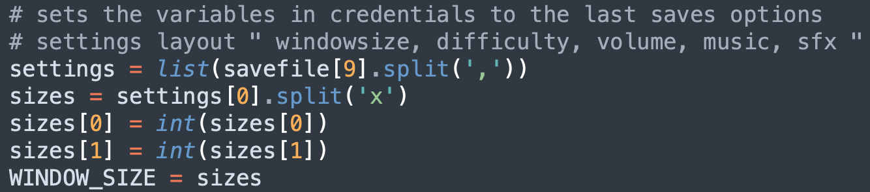

# Draft 9

In draft 9, I wanted to expand my map and stop using the one test CSV file, but instead create a connected map of CSV files, where leaving one will load the next. I also wanted to fix a couple issues I was having with my code and make my main script even simpler by exporting some of the calculations to the engine script.

I started by removing the Fullscreen functionality and opted out for another size. I decided to do this as I couldn’t find a way to fix this problem and I didn’t want to go back and change my screen dimensions for everything.

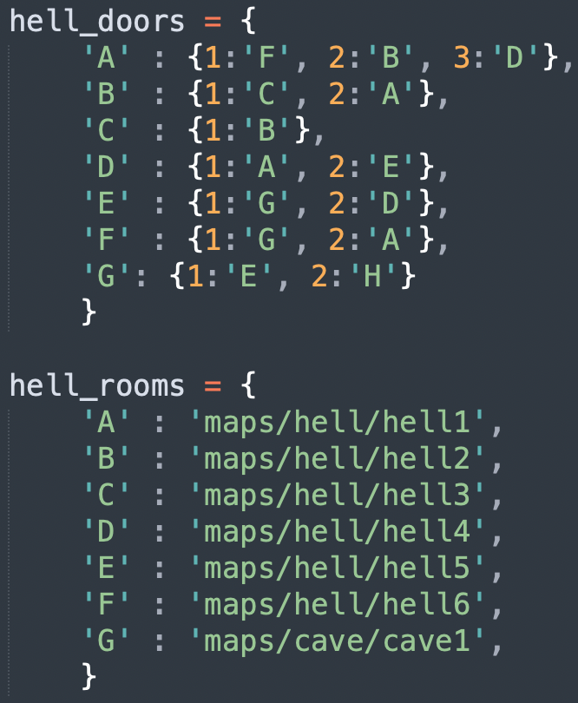I initially considered structuring my map in a 2D array of rooms, but upon further consideration, as I wanted some of my rooms to have two right exits, a 2D array wouldn’t have worked for this map structure without it becoming too complex. Therefore, after some thinking, I structured my map by using two dictionaries in a separate scripted called “room_data”. One determines how each room is related to the others, I structured it with a dictionary of dictionaries; a room ID is the key which returns a list of dictionaries. Each of those dictionaries related a door ID to the room ID it takes you to. I also decided to make my room IDs letters and door IDs numbers to make me less confused when trying to use this system. The other dictionary just simply related the room IDs to the CSV file path so that I can load them.

To expand my map, I developed the next part in my map class. This is so that everything would be encapsulated in the ‘gamemap’ object and make it easier to access the map’s data from the main code, including the different rooms, worlds, enemies and particles. Now the load function not only reads and loads the CSV file, but I made it create the tile objects; this was previously processed every frame in my game loop but now it’s only processed once when the room is loaded and therefore makes my game more efficient.

I started by creating a series of CSV files with empty tiles (doors) to the side. I then assigned a new value in my CSV files to represent doors, 13. Each door is handled separately in my load function, because it has no image, so it’s just a rect, I want to count each door and give it the respective door ID when loaded. 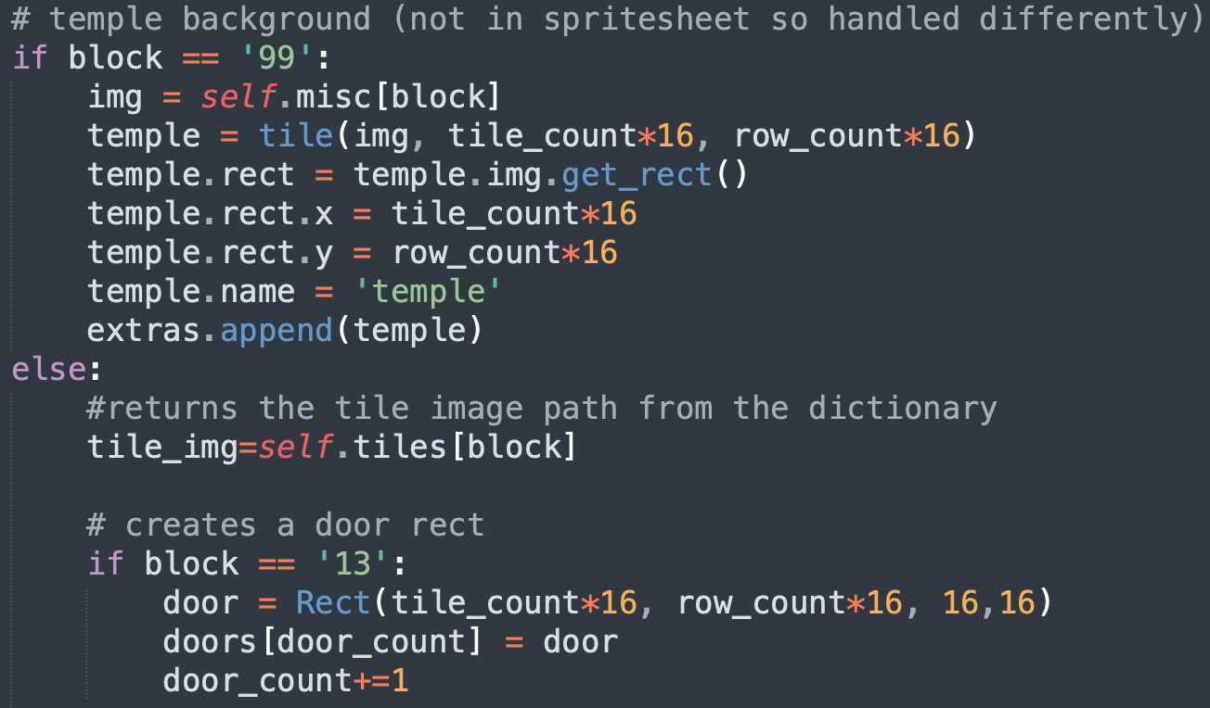

Doors aren’t the only thing I handle separately; I also handle miscellaneous objects, objects which their images are too big to be stored on a sprite sheet. For example, the temple is handled different but still has a value in the CSV file. When that value is found with separate ‘if’ statement, it’s image is found using the ‘misc’ dictionary instead of the ‘tiles’ dictionary and the image is appended to the ‘extras’ list instead of the ‘tiles’ list.

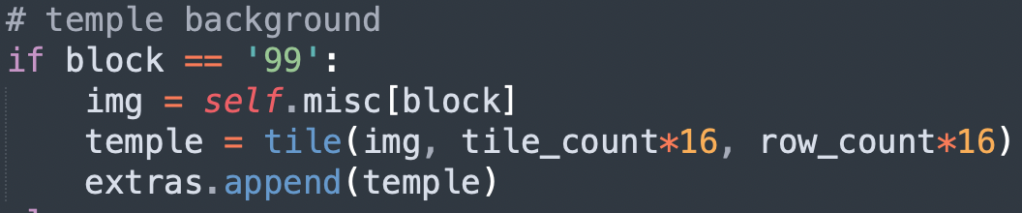

When the player collides with these door rects, the next room is loaded using the door ID and the two room data dictionaries. I also created ‘change’ and ‘get’ methods to retrieve and change the map’s data. The method ‘get door ID’ found the door ID from the dictionaries which was used when changing rooms. 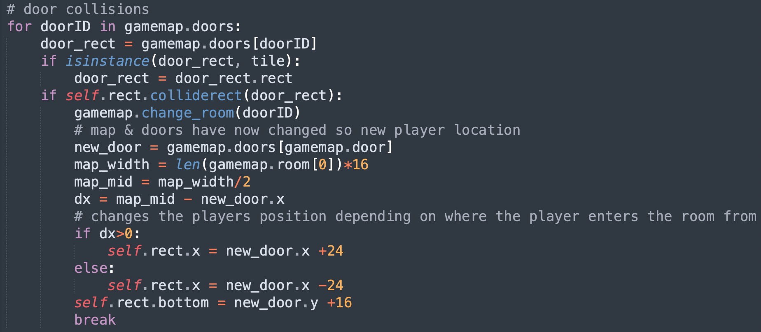

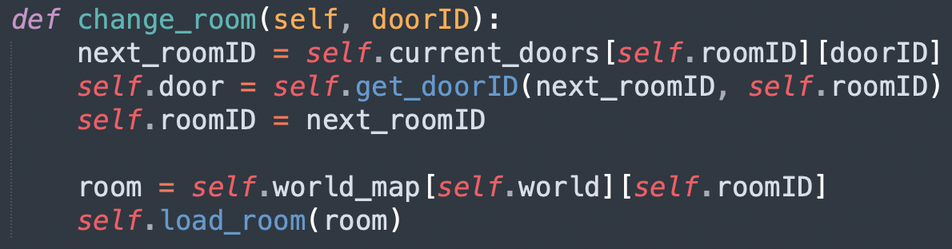

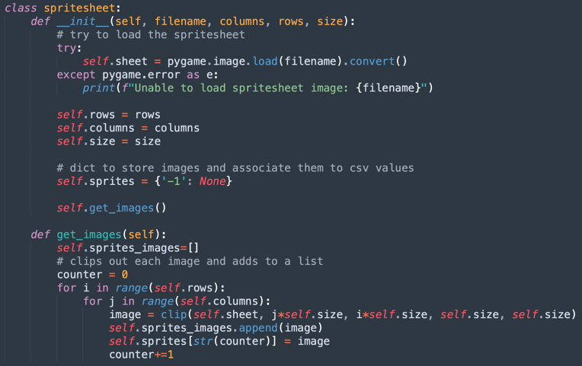Next, I wanted to load more images and different tile sets for different backgrounds and settings. So instead of having every image in a different dictionary in my main script, I decided to create a sprite sheet loader which takes a sprite sheet file and loads and cuts out each individual sprite out of the sheet using the “clip” function and stores it in its own dictionary all under the sheet object.

This came with a problem when cutting each sprite out though, I encountered some errors stating, “not enough memory”, so I decided to refactor my “clip” function in my engine script to make it simpler and more memory efficient.

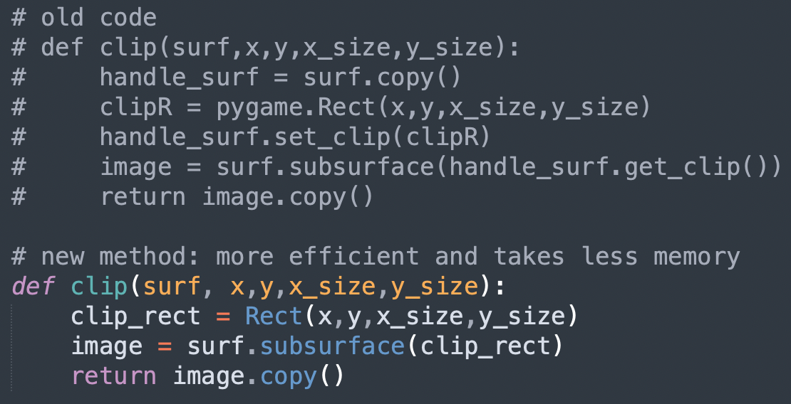

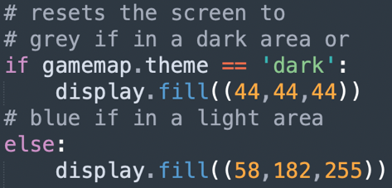As I created my sprite sheets all in the same orientation, the value for a type of tile (e.g., a corner tile) would be the same for each sprite sheet. So, all I need to do to switch between tile sets, is to call to a different sprite sheet. As the different tile sets have different themes (dark theme or light theme), I also created a theme attribute in my map class which is calculated whenever the change_world function is called. Then in my main code, I wrote a few lines of code which makes the background of the game grey if the tile set has a dark theme and sky blue if the tile set has a light theme.

Finally, I wanted to make some changes to the player. When created the maps, I created small tunnels in which the player cannot walk through, I made it so that the player needs to crawl through them. So next I implemented the crawling functionality. I started by creating the sprites for the crawling animation first and loaded it in my main script. Then I assigned a new keystroke, the ‘c’ key, to toggle the crawl action. The crawl animation will play if the player is crawling.

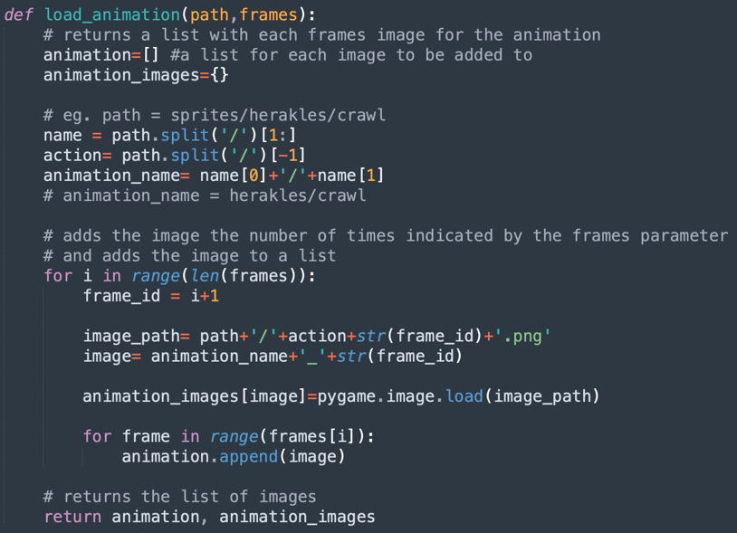

To load the animation, I created a new animation loader method in my animation class called “load_animation” and renamed my previous loader to “load_weapon_animation”. I had to do this as the previous loader only accepted file paths which had a weapon as a folder. As the crawl animation isn’t under a weapon folder, the animation wouldn’t load properly and caused errors in the program. So “load_animation” accepts animations without a weapon folder.

The first problem arose with the sprite size, as I made the crawl sprites much shorter than the standing sprites, when the user goes to crawl, the player starts in the air. This is because Pygame coordinates start from the top left and the coordinates do not get changed when the action changes, the game would detect the player is in the air and the jump animation would play instead; then as the jump sprite is taller than the crawl, the loop will restart. Making this system not work. I decided to make the crawl sprite taller by adding transparent pixels at the top of the image in my image editor.

This caused another error though. As the image is now larger, the rect would be of the same height as the rect of the normal standing sprite which wouldn’t fit in the tunnel. I then decided to use masks for collisions between the player and tiles as well. For this, I created a new method under the physics class called “tile_collisions” which uses the same process as the “tile_collisions_test” but uses masks after detecting a collision with the tile and player rects too.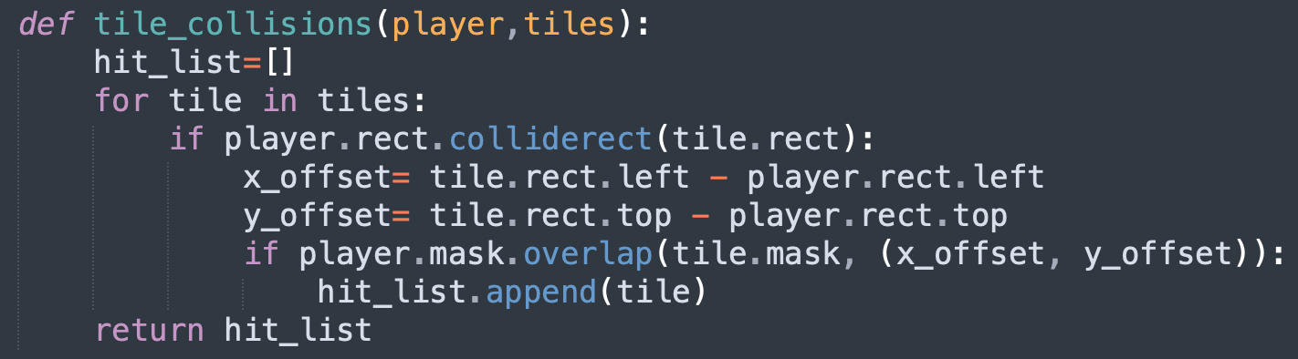

I also exported the game loop code from the main script which handles the player processes to the entity class under the method “move” to make my main loop code neater. I also created a new method called “get_input” in my entity class which would check for inputs what are being held down. Other inputs which check for key presses, I left in the main loop. 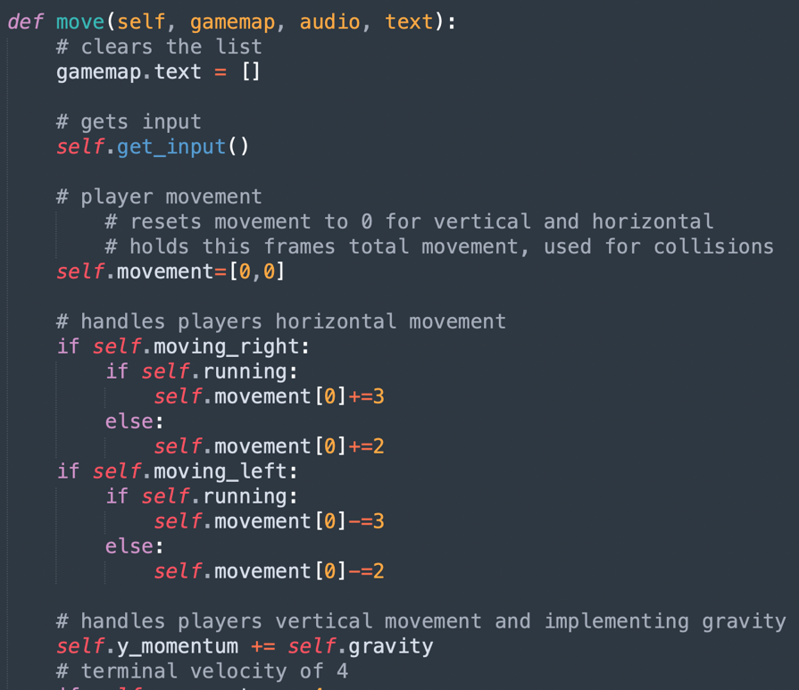

Also, although writing the method “set_anim_image” previously, I realised that I forgot to implement it in my main code, so I did at this stage.

# Draft 10

For this stage, my goals were to introduce some music, sound effects, allow for changing worlds, introduce different enemies and interactable items.

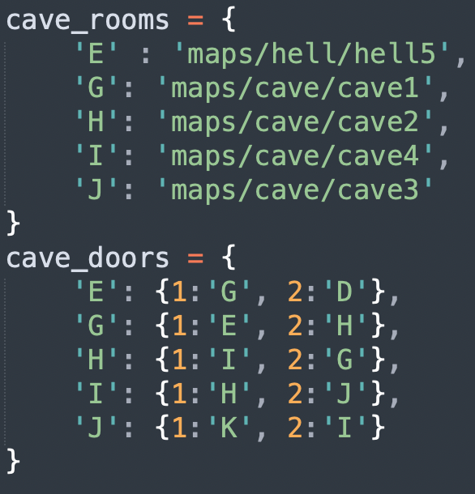

Firstly, as I previously developed for changing rooms, I wanted to develop changing the world. For this feature, instead of using invisible blocks, I decided to use a lightning bolt sprite as my ‘teleporter’ object. It took me a while to get my head around how to structure the new worlds, but I chose to create two new dictionaries for each world, one for the rooms file paths and the door connections (dictionary of dictionaries explain previously). With this new structure I can now link different world together. From now on, I will be creating two new dictionaries from each new world I try to create.

When the player collides with the lightning bolts, it’s handles slightly differently to normal doors, this is because in the main loop the map path is checked for check if the world is the same as the previous loop’s map, if not then the “change_world” method is called on my map object and the tile set is changed to the different world’s tile set. 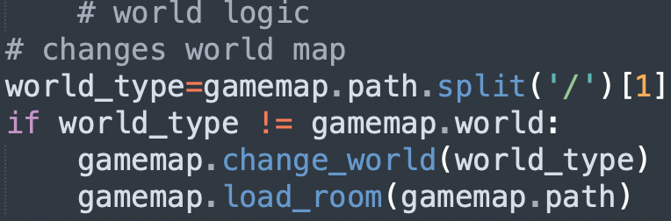

My next step was to create the enemies. I started by adding them to the sprite sheet and load them as an image, then I assigned each type of enemy to a value. I created three different types of enemies: a standard type, a bull type enemy, and a flying type enemy. Then I added these values in some of my CSV files and added a section in my map loader which checks for these values and creates a new enemy object.

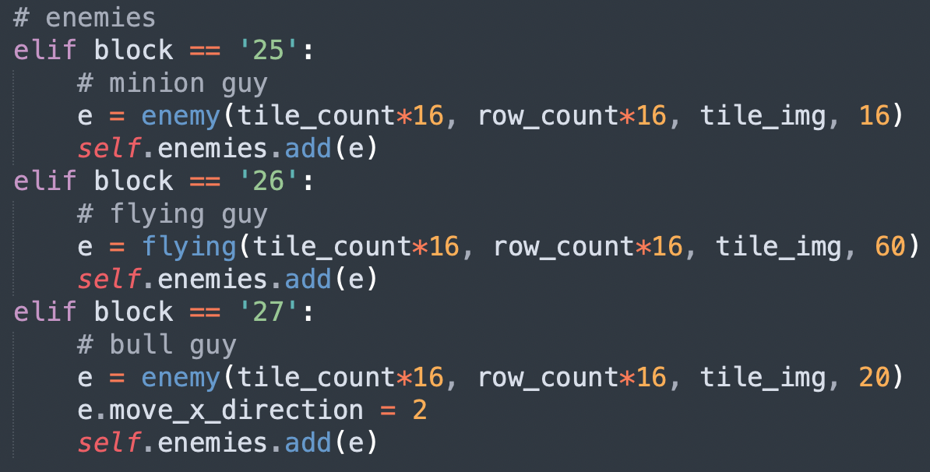

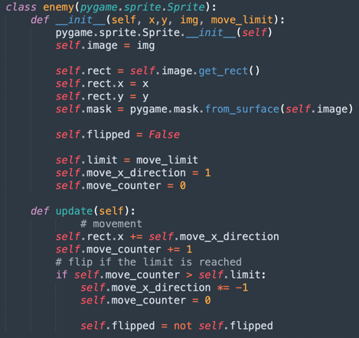The enemies above are created by enemy class which I made it so that it inherits from the Pygame Sprite class, the reason I made it inherit from the Sprite class is because you can group Sprite objects together which would be useful when trying to update and display all the enemies in the game loop as I can look through the one group.

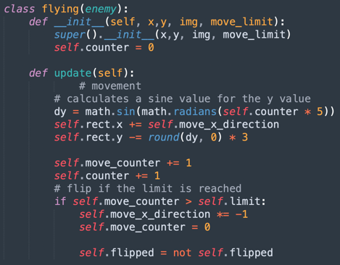I also created a child class of enemy called “flying_enemy”, it inherits the constructor but overwrites the update function because instead of moving side to side, flying type enemies would move in a figure eight. Creating the figure eight movement took some trigonometry to work out. As I made the enemy classes, I found it appropriate to rename the ‘entity’ class to ‘player’ because the class is only used for the player.

Next was allowing the player to kill the enemies and for the enemies to hurt the player. So first I check if the player is colliding with an enemy, if the player is attacking the enemy will die if not then the player will be damaged. The problem with this system is that because the game runs at 60 frames per second, the player would get damaged 60 times a second. My solution to this was to make the player invulnerable for a couple frames after he is damaged. To make it clear to the user that the player was damaged and that he is invulnerable, during this damaged period the player will glow red. 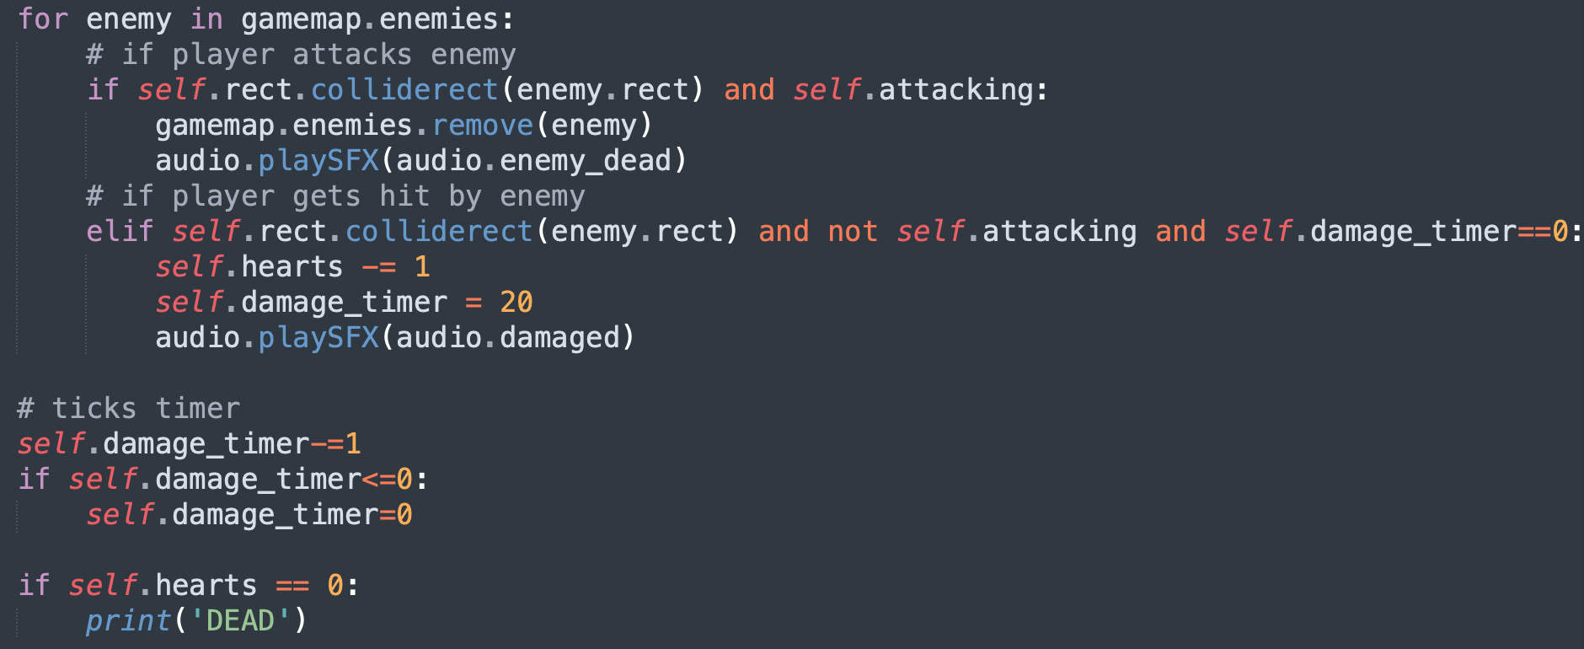

Next was to allow collisions between the arrows and enemies. To do this was relatively simple as I have already made a method under the particle class which checks for collisions called “tile_collisions”. As I will now be using this method for other objects instead of only tiles, I decided to rename the method to “collisions”. Then in the main loop, in the loop where I check for collisions between arrows and tiles, I added a new section which checks for collisions between arrows and enemies, if they collide then both arrow and enemy objects are destroyed.

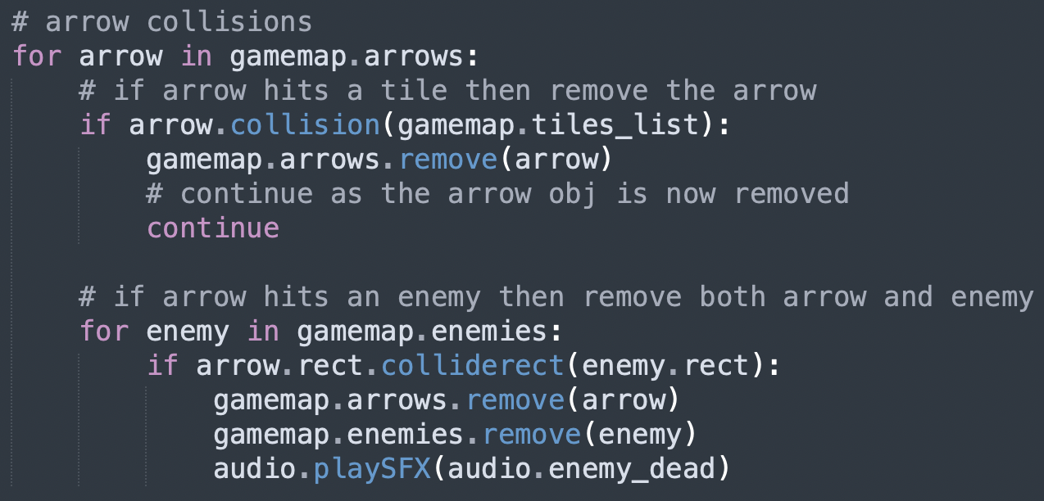

Having interactable objects in the game was the next step. These objects would be hearts, coins and arrows. When picking these objects up the player’s counters in the top left of the screen would increase. To do this, I first created the sprites and added them to the sprite sheet. I then assigned each interactable a number in the CSV files and added them to the rooms. Then in the map loader, I made it check for the interactables’ specific number and if there is one, it would create a tile object with the interactables’ sprite. Then as I would like to check for collisions with the player and these objects, I created a separate list called “items” and append each interactable alongside the item’s name within a tuple to this list, which is stored under the map object. Then in the player move function, I created a loop which checks for collision between the player and the items, then if true then the program looks at item’s name and increases the counter for that item type. For example, if the player collides with a heart, then the heart counter is increased.

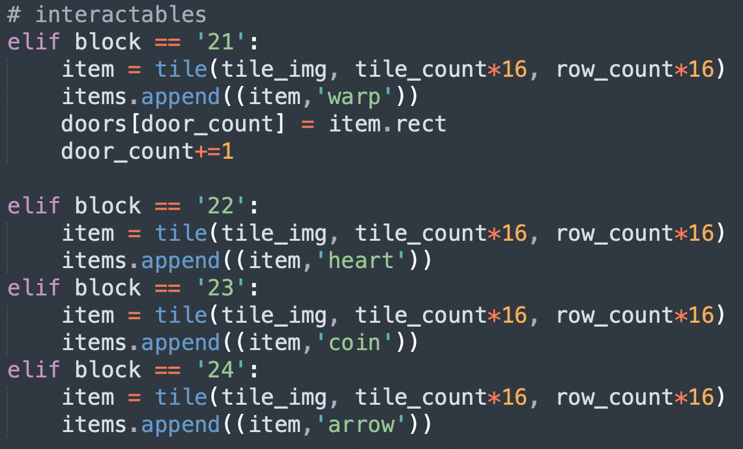

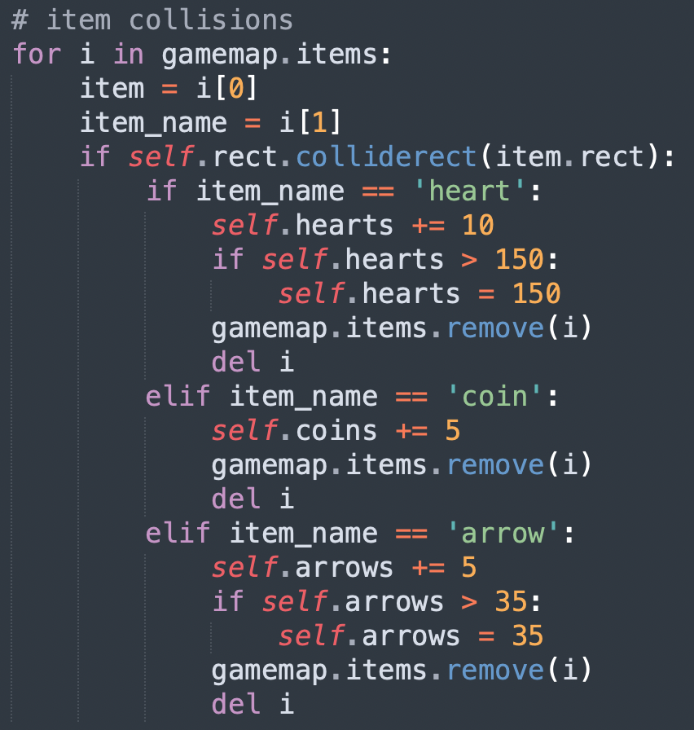

I made a few adjustments in the main script; I update the enemies after moving the player. Then display both the enemies and the interactable in the display section of my main loop. Another simple change is that arrows are not stored in a list in the main script, but now a list under the map object. This just further simplified the game as there now was only a few objects that make up the game: the player, the particles, the enemies, the interactables, the map. Of which the particles, enemies and interactables are stored within the map object itself.

Finally, the last step for this draft was to implement some music and sound effects, firstly I needed to initialise mixer at the start of my main script. I have two different soundtracks to play, one when there are enemies, my action soundtrack, and the other which plays when there are no enemies in the room, my calm soundtrack. To play the correct one, in the main loop the game checks if there are enemies in the room, using the “count_enemies” method of my map object. If the count is larger than one then the action soundtrack will play, else the calm soundtrack will play. 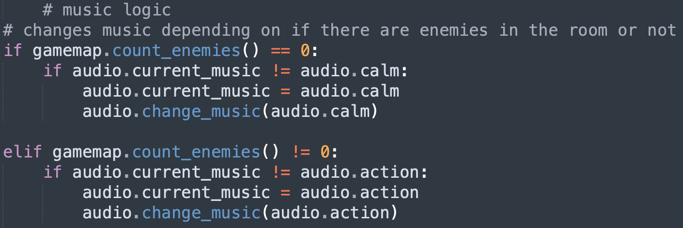

The sound effects I wanted to implement were bow shooting, jumping, dying, enemies dying, walking. I play these sounds when these actions are done. But one effect I did remove was the walking sound effect as it is too loud and annoying for the user and when the walking sound effect is playing, the more important sounds can’t play at the same time which caused issues. Some of these have been shown in previous screenshots within this draft.

# Draft 11

In the eleventh draft I wanted to develop the saving feature and making the player die when his health reaches zero. These are the final features that I will add to the game. At the end of draft, the game will be able to be played properly as all the functionalities and game mechanics would be developed. All I would have to do is add NPCs, expand the map and create the story with bosses.

I wanted to develop the saving mechanics. I have already put the temples in the game which are the save points. All I must do is allow for saving from these temples. Firstly, I had to adjust the temple rects from the small 16x16 tile sizes to the actual image size. I done this in the room loader module. 

Then, I wanted text prompting the user to save by pressing the interact button (the key v) when touching with the temple. I detected the collision in the player’s move function. Which if colliding with the temple, the text “Save – V” would be added to the gamemap’s text list along with the coordinates in which it would need to be displayed, above the temple image. This text list is emptied every game loop iteration before the detection, which makes it so that the text only displays when the player is colliding with the temple. The text is then rendered using the font object and displayed in the main game loop. 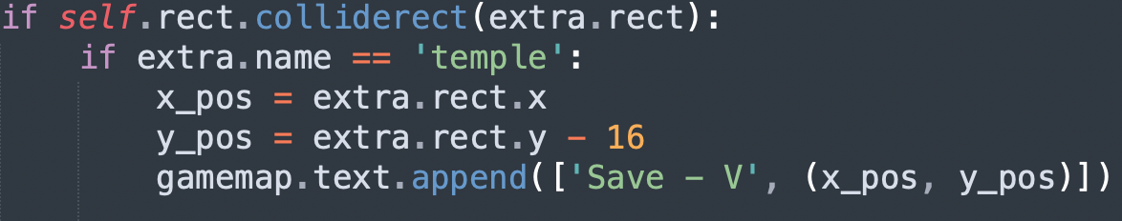

Next, was to check if the user is interacting with the temple, so in the same if statement from before, if the player is touching the temple and is interacting, then the “save” function of the database script is called to save the player’s numbers and position. Before saving, I wanted some confirmation from the user, so I implemented a Tkinter pop up window which asks the user if they wish to save. Only if so, will the data be saved. For the Tkinter pop up, I initialised and withdrew before the pop up then terminated Tkinter right after.

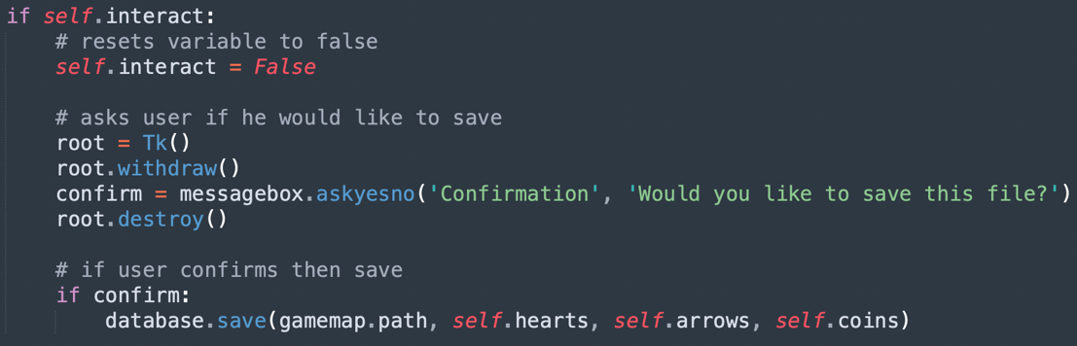

Finally, to see if this feature works, I altered my main loop to read the save file and assign the data from the save file to the player’s attributes before the main game loop starts. This only allowed me to see if the player’s numbers (hearts, arrows and coins) were saved though. So, to check if the save point location worked too, I created another room in the cave map section to also check if spawning into another world would work too and use the appropriate tile set.

The next mechanic to develop was the death of the player. For this, I check if the player’s hearts are equal to or less than zero in the main game loop, then if they are, load the death screen which is like the title screen and asks for the space bar input to continue. Then the latest save file is loaded into the main script which loads the game from the last point which the user saved from. Finally, I added a death sound effect which would play when the player dies. 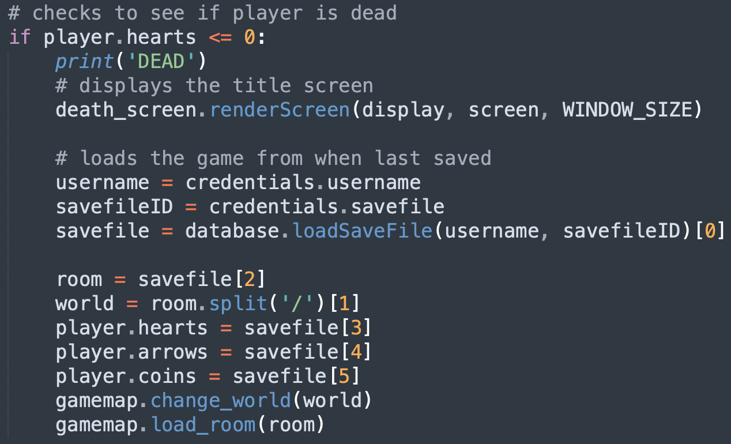

I also made some adjustments to the player’s action mechanics. One adjustment was to make the player unable to jump when crawling, I made this adjustment as I noticed that when I’d let stakeholders test the game, they would frequently try to jump in the tunnels which would bug the collision system and teleport the player out of the map.

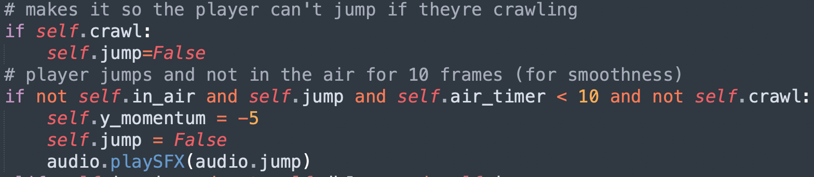

The next adjustment was with the player’s attacks. I adjusted attacking with the sword/club so that the player can only attack with these weapons when on the floor and not in the air.

The other adjustment with these weapons is that collisions between player and enemies would only kill enemies when using these weapons, this removed the fact that when using the bow, the user would shoot at one enemy and walk into another and kill both. So, when using the bow, the player will always get damaged if they touch an enemy. 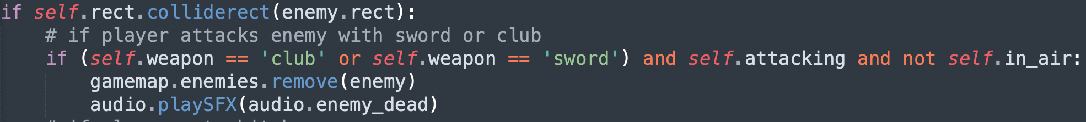

# Testing

DRAFT X

PROBLEM

SOLUTION

TESTING

# Evaluation

* Success criteria
* Met?
* Evidence
* Usability features - keys
* Limitations - only on PC
* Maintenance - none

# Final scripts